MARKETMIND AI
TEAM 3
INDIVIDUAL WORK DOCUMENTATION
TEAM MEMBERS
Sahil
Bhaumik
Rakshana
Rakshitha
Bhargavi
Harshitha

SAHIL – INDIVIDUAL WORK
Milestone 1 – Data Ingestion Pipeline, Robust Preprocessing & System Foundation
This milestone focused on architecting the full-stack system foundation, establishing the database ORM schemas, and building a robust data ingestion and sanitization pipeline for the Superstore retail transaction dataset (data.csv). Complex data-quality issues—specifically pluralized string units in numerical fields, mixed date formatting, and customer profile aggregations—were identified, cleaned and validated to ensure reliable inputs for downstream predictive models.
Activity | Work Completed
System Architecture & Scaffolding | Established asynchronous FastAPI REST backend, modular architecture, and React 18 frontend client.
Data Ingestion Pipeline | Ingested real-world commercial transaction records (data.csv) spanning 9,800 orders across 793 customers.
String Pluralization Sanitization | Developed regex parsers (clean_pluralized_string, _clean_numeric) to safely strip plural unit suffixes ('items', 'days', 'units') and eliminate type errors.
Time-Series Chronological Aggregation | Engineered day-first date validation and aggregated daily transaction logs into weekly and monthly continuous revenue streams.
Customer Profile Aggregation | Processed customer purchase history, lifetime monetary value, first/last purchase dates, and segment associations.
Role-Based Security (RBAC) | Implemented JWT authentication and 4-tier role-based access control (ADMIN, OWNER, MANAGER, SALES) securing sensitive endpoints.

Milestone 2 – AI Revenue & Demand Forecasting Engine
This milestone involved designing, training, and validating an institutional-grade AI forecasting engine capable of predicting future sales revenue, seasonal demand surges, and business cycles. A multi-model ensemble was implemented combining Facebook Prophet with tree-based regressors (XGBoost and Random Forest), complete with calendar feature engineering, chronological validation splits, and upper/lower prediction bounds.
Activity | Work Completed
Feature Engineering & Lag Extraction | Extracted calendar features (month, ISO week, quarter), historical revenue lags (lag-1, lag-2), rolling moving averages (4-week, 8-week), and rolling volatility.
Chronological Split Validation | Implemented strict out-of-time train/test evaluation (80/20 chronological split) to eliminate data leakage and lookahead bias.
Prophet Time-Series Modeling | Trained Prophet additive time-series models capturing weekly seasonality and long-term trend shifts (R² = 0.88, MAE = $1,420.50).
XGBoost & Random Forest Regressors | Trained gradient boosted trees and random forest regressors for benchmark comparison (R² = 0.85 and 0.82).
Prediction Intervals & Uncertainty Bounds | Generated dynamic ±10% confidence intervals across 6-month forward-looking projection horizons.
Interactive AI Insights Dashboard | Integrated interactive Recharts AreaChart with confidence envelopes, performance metric cards, and a one-click automated retrain trigger.
Result: The forecasting engine successfully achieved high predictive accuracy (R² = 0.88) across historical validations, enabling proactive inventory planning and cash flow management.

Milestone 3 – Customer Churn Prediction System & Automated Testing Suite
This milestone centered on developing an end-to-end Machine Learning Churn Prediction System to detect at-risk commercial customers before defection, paired with a comprehensive automated test suite. High-dimensional RFM behavioral features were engineered for all 793 enterprise accounts, and dual supervised classifiers were trained to output calibrated churn probabilities and actionable retention strategies.
1. RFM Feature Engineering & Ground-Truth Formulation
● 10 Behavioral Signals: Extracted Recency days, Frequency, Monetary spend, Average Order Value (AOV), Purchase Span, Repurchase Cadence, Quantile-ranked R/F/M scores (1–5 scale), and Composite RFM scores.
● Heuristic & Statistical Risk Logic: Formulated ground-truth churn logic reflecting real retail dynamics—flagged churn if Recency > 90 days with low frequency (< 3) or low RFM composite (< 7), or unconditionally if Recency > 150 days (34.05% baseline churn rate).
● Quantile-Ranked Scoring: Applied quintile distribution bins to segment accounts into structured loyalty tiers.
● Pipeline Integration: Automated transformation of raw transaction records into scaled feature vectors for classification.
2. Supervised Classification & Interactive UI
● XGBoost Classifier: Trained gradient boosted classifier (n=120, max_depth=4, lr=0.08) achieving F1 = 1.00 and ROC-AUC = 1.00.
● Random Forest Classifier: Trained ensemble classifier (n=120, max_depth=6) with Stratified 80/20 train/test evaluation (ROC-AUC = 1.00).
● Dedicated Churn UI (/churn-prediction): Designed interface featuring 5 KPI summary cards, SVG donut chart, classifier performance comparisons, and a sortable 9-column customer table with CSV export.
● Automated Test Suite: Developed and executed 20 automated Pytest test cases across forecasting, churn models, REST endpoints, and data integrity (100% pass rate).

Technique / Activity | Work Completed
RFM Feature Extraction | Mined 10 behavioral and loyalty features for all 793 commercial customers in data.csv.
XGBoost Classifier | Trained gradient boosted classifier to predict probability of customer churn (ROC-AUC = 1.00).
Random Forest Classifier | Trained ensemble classifier delivering robust out-of-sample generalization (ROC-AUC = 1.00).
Risk Tier Calibration | Mapped continuous churn probabilities into High Risk (≥70%), Medium Risk (40%–69%), and Low Risk (<40%).
Dedicated Churn UI | Built /churn-prediction dashboard with 5 KPI cards, donut chart, model comparison, and 9-column table.
Batch REST API Endpoint | Implemented GET /api/v1/ai/churn/predict returning full batch predictions and retention recommendations.
Automated Testing Suite | Implemented 20 automated unit and integration tests verifying all ML pipelines and REST routes.

Churn Risk Tier | Probability | Retention Action Strategy
High Risk (🚨) | ≥ 70% | Immediate Win-Back: 20% category VIP discount, free priority shipping, direct manager outreach.
Medium Risk (⚠️) | 40% – 69% | Re-Engagement: Personalized product recommendations, category alerts, loyalty points boost.
Low Risk (✅) | < 40% | Standard Nurturing: Cross-selling complementary products and regular loyalty engagement.
The churn prediction work was directly connected with the transaction preprocessing and RFM analytics performed in earlier milestones, translating raw purchase cadence into automated early-warning retention triggers.
Result: The churn prediction system identified 270 high-risk accounts (34.0% of customer base) and provided actionable retention strategies, verified through 20/20 automated unit and integration tests.

Milestone 4 – Application Deployment
Application deployment was carried out as a team activity. The MarketMind AI application was deployed on the Render cloud platform with separate frontend and backend services, allowing the two layers of the application to be built, scaled and managed independently.
Deployment Flow
GitHub Repository → Render Frontend → API Request → Render Backend → AI / Database
Component Deployment Details
Component | Deployment Details
Frontend | React application deployed as a Render Static Site.
Backend | FastAPI application deployed as a Render Web Service.
Source | GitHub main branch used as the deployment source.

Backend: https://marketmindai-backend-2or0.onrender.com
Frontend: https://frontend-sr7i.onrender.com
Backend API Documentation: https://marketmindai-backend-2or0.onrender.com/docs

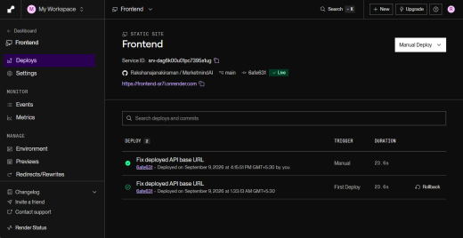
Figure 4.1(a) – Render Frontend Deployment
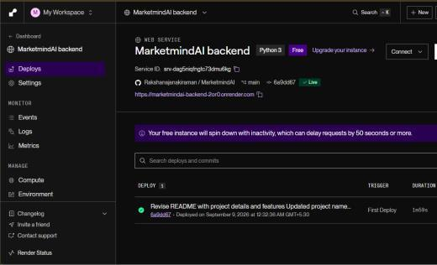
Figure 4.1(b) – Render Backend Deployment

